**American Football Positions**

From Wikipedia, the free encyclopedia

No higher resolution available.

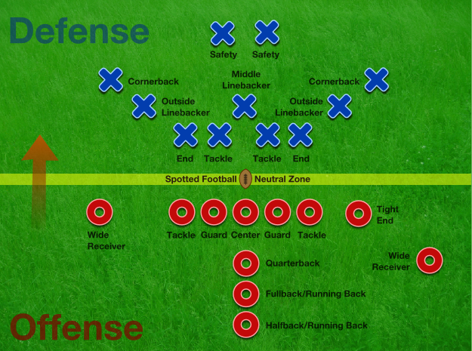

[American_Football_Positions2.png](http://upload.wikimedia.org/wikipedia/commons/2/2c/American_Football_Positions2.png)‎ (625 × 465 pixels, file size: 578 KB, MIME type: image/png)



**Summary**

|  |  |
| --- | --- |
| **Description** | American Football Positions2.png  **English:** American football field posistions |
| **Date** | 28 November 2008(2008-11-28) |
| **Source** | Own work |
| **Author** | [RegisFrey](http://commons.wikimedia.org/wiki/User:RegisFrey) |
| **Permission (**[**Reusing this file**](http://commons.wikimedia.org/wiki/Commons:Reusing_content_outside_Wikimedia)**)** | See below. |
| **Other versions** | American Football Positions2.svg |

grass image by Birdie777 on Flicker under Creative Commons Attribution 2.0

[**Licensing**](http://commons.wikimedia.org/wiki/Commons:Copyright_tags)

|  |  |  |  |  |  |
| --- | --- | --- | --- | --- | --- |
| **I, the copyright holder of this work, hereby publish it under the following license:**   |  |  |  | | --- | --- | --- | |  | This file is licensed under the [Creative Commons](http://en.wikipedia.org/wiki/en:Creative_Commons) [Attribution 3.0 Unported](http://creativecommons.org/licenses/by/3.0/deed.en) license. |  | |  | | You are free:   * **to share** – to copy, distribute and transmit the work * **to remix** – to adapt the work   Under the following conditions:   * **attribution** – You must attribute the work in the manner specified by the author or licensor (but not in any way that suggests that they endorse you or your use of the work).   www.creativecommons.org/licenses/by/3.0 CC-BY-3.0 Creative Commons Attribution 3.0 truetrue | |

**File history**

Click on a date/time to view the file as it appeared at that time.

|  |  |  |  |  |  |  |  |  |  |  |  |  |
| --- | --- | --- | --- | --- | --- | --- | --- | --- | --- | --- | --- | --- |
|  | | | **Date/Time** | | | **Thumbnail** | | **Dimensions** | | **User** | **Comment** | |
|  | | | [04:24, 11 January 2009](http://upload.wikimedia.org/wikipedia/commons/2/2c/American_Football_Positions2.png) | | |  | | 625×465 (578 KB) | | RegisFrey |  | |
|  |  | |  |  | |  | |  | | |
|  | | | [05:39, 28 November 2008](http://upload.wikimedia.org/wikipedia/commons/archive/2/2c/20090111042437%21American_Football_Positions2.png) | | |  | | 625×465 (578 KB) | | RegisFrey | ({{Information |Description={{en|1=American football field posistions}} |Source=Own work by uploader |Author=[RegisFrey](http://en.wikipedia.org/wiki/User:RegisFrey" \o "User:RegisFrey) |Date=November 28 2008 |Permission= |other_versions=American Football Positions2.svg }} grass image by Birdie777 on Fl) | |

**File links**

The following pages on the English Wikipedia link to this file (pages on other projects are not listed):

[American football rules](http://en.wikipedia.org/wiki/American_football_rules)